## Designing Pages Layouts for a Publishing Site

**Lab Time**: 45 minutes

### Exercise 1: Creating Custom Page Layouts

In this exercise you will work with page layouts. This lab assumes that you have completed all the steps of the previous lab (Lab 6) in which you uploaded and configured the custom master page named **wingtip.master**.

1. Launch the browser and navigate to **http://[[PUBLISHING_SITE]]**. Note that you should at first access the site with anonymous access. Click the **sign in** link to authenticate. Log in using the credentials of the site collection owner Ken Sanchez, which are **[[AD_DOMAIN]]\ken**. You should already have the custom master page named **wingtip.master** configured as the master page due to work you did in the previous lab.

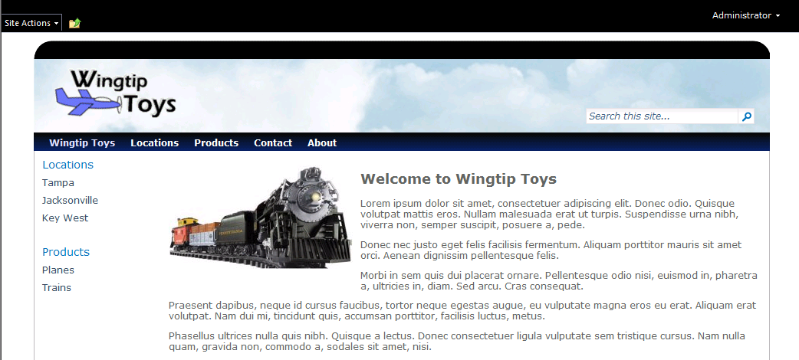

1. Select **Site Actions » Site Settings**.
2. Select **Galleries** **»** **Site columns**. You will see all the existing site columns for the current site.

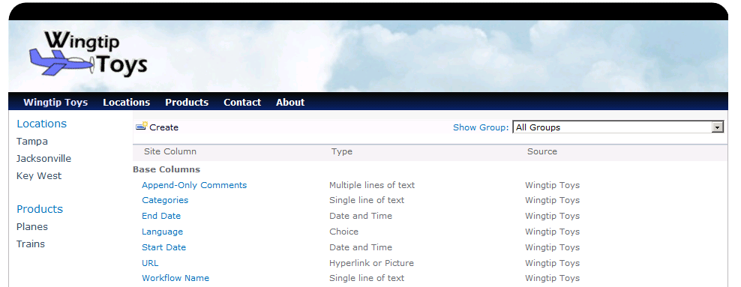

1. At the bottom of the Site Column Gallery page you should be able to see that there are already a few custom site columns that have been added to a group named **Wingtip Site Columns**.

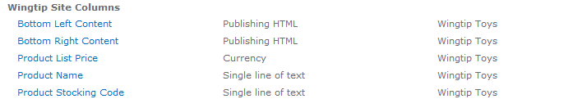

1. To create a new column, click **Create**. On the **New Site Column** page use the following information to create a new site column:
   1. **Column Name**: Driving Directions
   2. **Type of information in this column is**: Full HTML content with formatting and constraints for publishing
   3. **Group**: Existing Group » Wingtip Site Columns

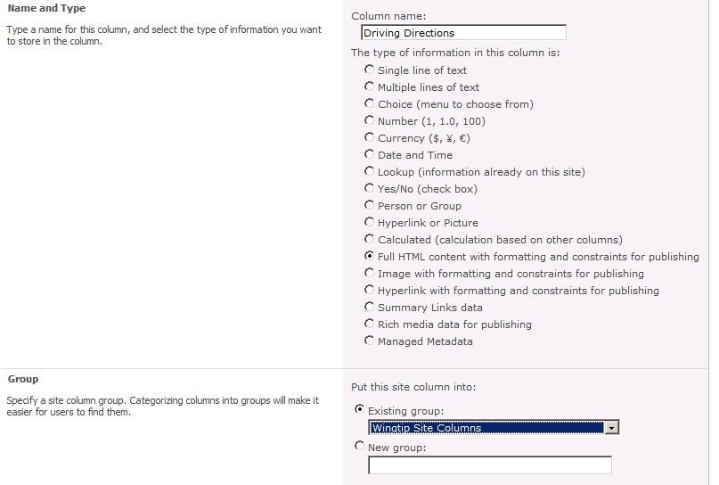

1. Create another site column using the following details:
2. **Column Name**: Store Hours
   1. **Type of information in this column is**: Full HTML content with formatting and constraints for publishing
   2. **Group**: Existing Group » Wingtip Site Columns
3. After you have created these two site columns, you should be able to verify that you have added them to the site column gallery.

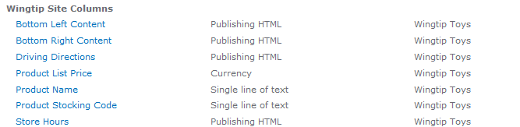

Now that you have created two site columns in the browser, you will now create a content type using SharePoint Designer. The content type will utilize the two site columns you just created, and it will serve as a publishing content type for a custom page layout.

1. Launch SharePoint Designer and open the site at **http://[[PUBLISHING_SITE]]**. When you are prompted for login credentials use **[[AD-DOMAIN]]\ken** to log in as the site collection owner Ken Sanchez.
2. Select **Content Types** in the Navigation Pane.

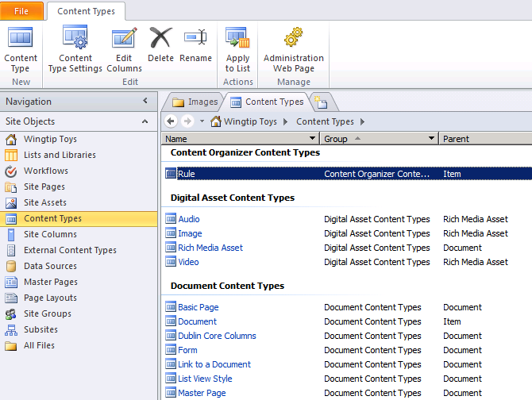

1. If you scroll down the set of available content types, you should see that there is a group named **Wingtip Content Types** that already contains two custom Content Types.

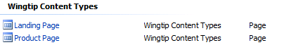

1. Click the **Content Type** button in the ribbon. The **Create a Content Type** dialog box comes up. Use the following information to create the content type:

**Name:** Store Location Page

**Select parent content type from:** Page Layout Content Types

**Select parent content type:** Article Page

**Group:** Existing Group » Wingtip Content Types

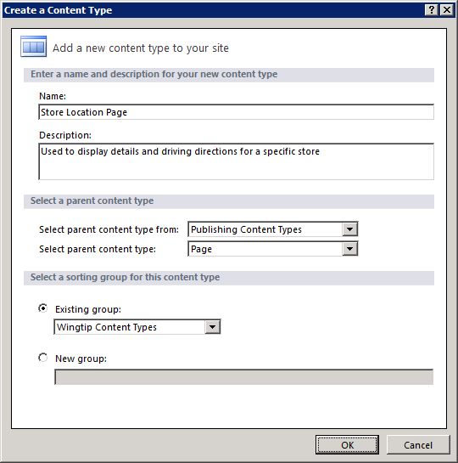

1. After creating the content type, select it from the list of available content types to open its **Summary Page**.
2. Click the **Edit content type columns** link under the **Customization** section. All the current Site Columns for this Content Type should now be displayed.
3. You will now add the two Site Columns that are provided in every Publishing site. Click the **Add Existing Site** **Column** button in the ribbon and scroll down to the section with the caption of **Page Layout Columns**. Select **Page Content** from the **Site Columns Picker** dialog box and click **OK**.

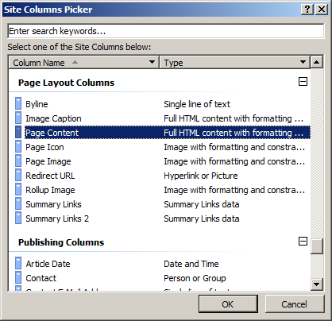

1. Repeat the process to add the **Page Image** Site Column.
2. You will now add the two Site Columns that you created earlier that are specific to the Wingtip publishing site. Click the **Add Existing Site** **Column** button in the ribbon and scroll down to the section with the caption of **Wingtip Site Columns**. Select **Driving Directions** from the **Site Columns Picker** dialog box and click **OK**.

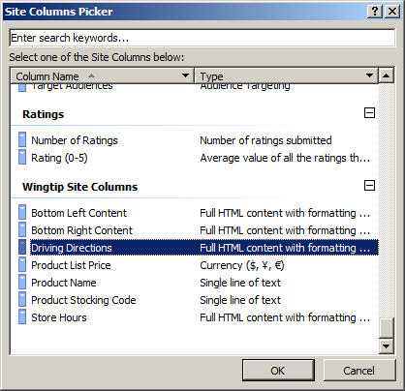

1. Repeat the process to add the **Store Hours** Site Column.
2. After adding the **Driving Directions** and **Store Hours** Site Columns, your content type should have the columns shown in the following screenshot. Click the **Save** button to save this Content Type.

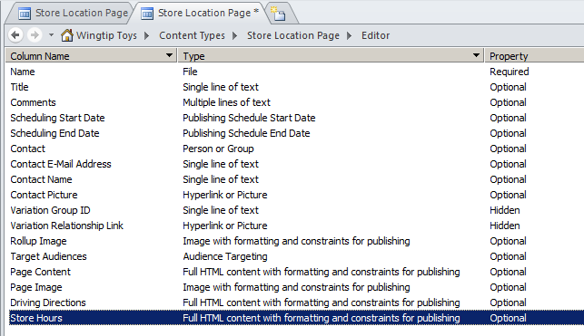

You will now create a page layout based upon this Content Type.

1. Click **Page Layouts** in the Navigation Pane. You should now see all the Page Layouts that exist on this site.

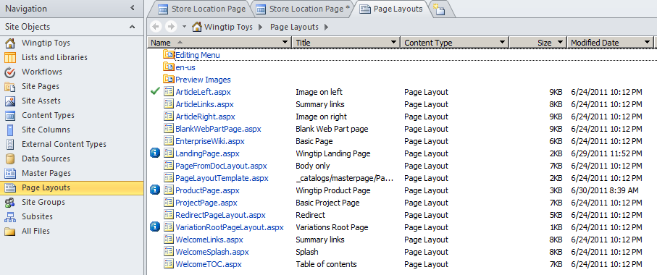

1. Click the **New Page Layout** button in the ribbon’s **New** group. From the **New** dialog box that opens, use the following:

**Content Type Group:** AW

**Content Type Name:** Press Release Page

**URL Name:** PressRelease.aspx

**Title:** Press Release

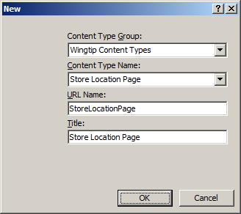

1. Click the **OK** button.
2. The **Store Location Page** should now automatically open in SharePoint Designer 2010.

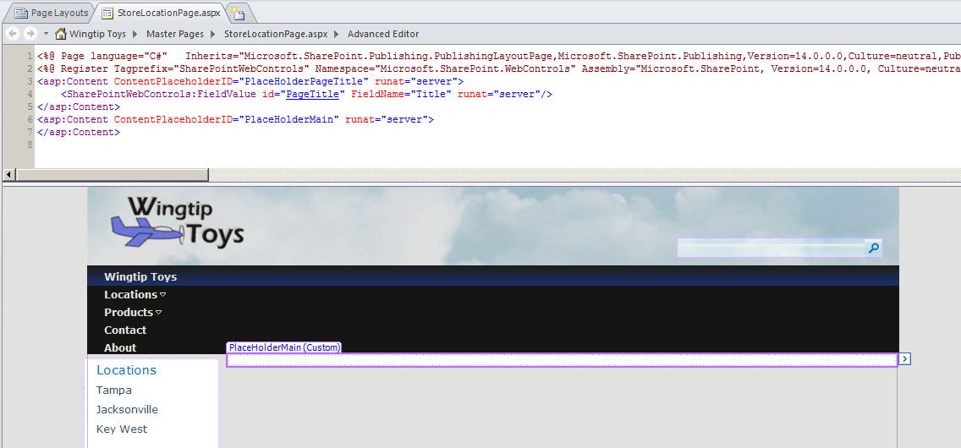

1. Place the cursor in the **PlaceHolderMain**.
2. Add the **PublishingWebControls.EditModePanel** control and then inside this control add an instance of the **SharePointWebControls:TextField** control.

<asp:Content ContentPlaceholderID="PlaceHolderMain" runat="server">

<PublishingWebControls:EditModePanel runat="server" CssClass="edit-mode-panel" >

<SharePointWebControls:TextField runat="server" FieldName="Title" />

</PublishingWebControls:EditModePanel>

</asp:Content>

1. Below the **EditModePanel** control, add a layout of div elements as shown in the following listing.

<asp:Content ContentPlaceholderID="PlaceHolderMain" runat="server">

<PublishingWebControls:EditModePanel runat="server" CssClass="edit-mode-panel" >

<SharePointWebControls:TextField runat="server" FieldName="Title" />

</PublishingWebControls:EditModePanel>

<div id="top_content">

<div id="page_image">

</div>

<div id="page_content">

</div>

<div style="clear: both;" ></div>

</div>

</asp:Content>

1. Now it is time to add field controls to the page layout using the SharePoint Designer toolbox. If Toolbox is not present in the Task Pane, click the **View** tab, then from the **Task Pane** button in the ribbon, select the **Toolbox** selection.

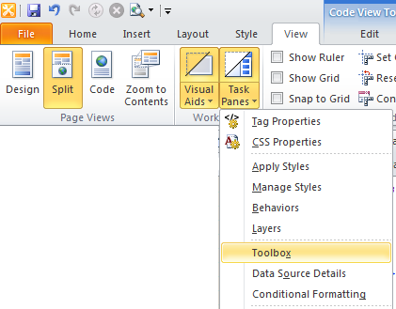

1. Examine the different sections inside the toolbox. In particular, examine the controls available in the two sections named **Page Fields** and **Content Fields**. These represent site columns defined in the **Store Location Page** content type. This is the content type associated with this page layout.

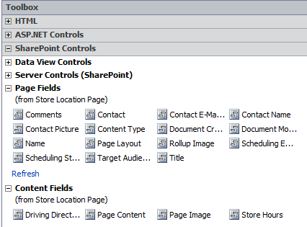

1. In Code view, place your cursor inside the div element with an **id** of **page_image**. Next, double-click on the **Page Image** field inside the toolbox. This will generate a **RichImageField** field control for the **Page Image** site column at the location where you have placed the cursor.

<div id="top_content">

<div id="page_image">

<PublishingWebControls:RichImageField

FieldName="3de94b06-4120-41a5-b907-88773e493458" runat="server" />

</div>

<div id="page_content">

</div>

<div style="clear: both;" ></div>

</div>

1. Place your cursor inside the div element with an **id** of **page_content**. Next, double-click on the **Page Content** field inside the toolbox to generate a RichHtmlField field control for the **Page Content** site column**.**

<div id="top_content">

<div id="page_image">

<PublishingWebControls:RichImageField

FieldName="3de94b06-4120-41a5-b907-88773e493458" runat="server" />

</div>

<div id="page_content">

<PublishingWebControls:RichHtmlField

FieldName="f55c4d88-1f2e-4ad9-aaa8-819af4ee7ee8" runat="server" />

</div>

<div style="clear: both;" ></div>

</div>

1. Under the **top_content** div, add a second div element with an id of **bottom_content**.

<div id="top_content">

<div id="page_image">

<PublishingWebControls:RichImageField

FieldName="3de94b06-4120-41a5-b907-88773e493458" runat="server" />

</div>

<div id="page_content">

<PublishingWebControls:RichHtmlField

FieldName="f55c4d88-1f2e-4ad9-aaa8-819af4ee7ee8" runat="server" />

</div>

<div style="clear: both;" ></div>

</div>

<div id="bottom_content">

</div>

1. Inside the **bottom_content** div, add a table with a single row and two columns using the following HTML layout.

<div id="bottom_content">

<table style="width:100%">

<tr>

<td style="vertical-align:top; width:50%">

<h3>Driving Directions</h3>

</td>

<td style="vertical-align:top; width:50%">

<h3>Store Hours</h3>

</td>

</tr>

</table>

</div>

1. Add a field control for the **Driving Directions** site column.

<div id="bottom_content">

<table style="width:100%">

<tr>

<td style="vertical-align:top; width:50%">

<h3>Driving Directions</h3>

<PublishingWebControls:RichHtmlField

FieldName="3f81d3ca-acb5-4720-94e5-8533e103eaf8" runat="server">

</PublishingWebControls:RichHtmlField>

</td>

<td style="vertical-align:top; width:50%">

<h3>Store Hours</h3>

</td>

</tr>

</table>

</div>

1. Add a field control for the Store Hours site column.

<div id="bottom_content">

<table style="width:100%">

<tr>

<td style="vertical-align:top; width:50%">

<h3>Driving Directions</h3>

<PublishingWebControls:RichHtmlField

FieldName="3f81d3ca-acb5-4720-94e5-8533e103eaf8" runat="server">

</PublishingWebControls:RichHtmlField>

</td>

<td style="vertical-align:top; width:50%">

<h3>Store Hours</h3>

<PublishingWebControls:RichHtmlField

FieldName="b1eb2cfe-abd1-404a-8853-1048b5f2fe20" runat="server">

</PublishingWebControls:RichHtmlField>

</td>

</tr>

</table>

</div>

1. Place the cursor above **PlaceHolderMain** and add a new section for **PlaceHolderAdditionalPageHead**. Add the CSS rules shown in the following listing.

<asp:Content ContentPlaceHolderID="PlaceHolderAdditionalPageHead" runat="server">

<style type="text/css">

#top_content { margin: 8px;padding: 8px; border: 1px #AAA solid;}

#page_image { float:left; margin:10px; }

#page_content { padding: 0px; }

#bottom_content { padding: 8px; }

#bottom_content table td {display:table-cell; padding: 12px;}

</style>

</asp:Content>

1. Press the F5 key to see how the page layout looks in the designer window of SharePoint Designer.

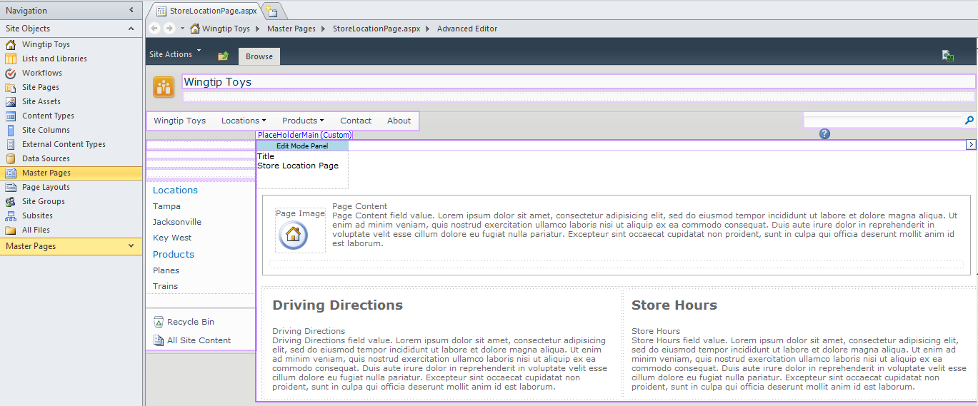

At this point, you are done implementing the Store Location page layout. The next steps are to check in and to approve this page layout so you can use it in a page.

1. In SharePoint Designer, click **Page Layouts** in the Site Objects section. Right click the StoreLocation.aspx file and click **Check In** from the popup menu.
2. From the **Check In** dialog box that appears, click **Publish a major version** radio button and then click the **OK** button.
3. A dialog box appears notifying you that: "This document requires content approval. Do you want to view or modify status?" Click the **Yes** button.
4. A browser window should open up showing you your submission to the **Master Page and Page Layout** gallery.
5. Hover over the **Store Location** page and click the drop down menu. Select the **Approve/Reject** option. In the **Approve/Reject** prompt that appears, click the **Approved** radio button and click the **OK** button.
6. The Page Layout StoreLocation.aspx is now approved.
7. Navigate to a publishing page in the **Locations** site such as **Tampa.aspx** and move the page into Edit Mode. From the **Page** tab, drop down the **Page Layout** menu and select **Store Location Page**.

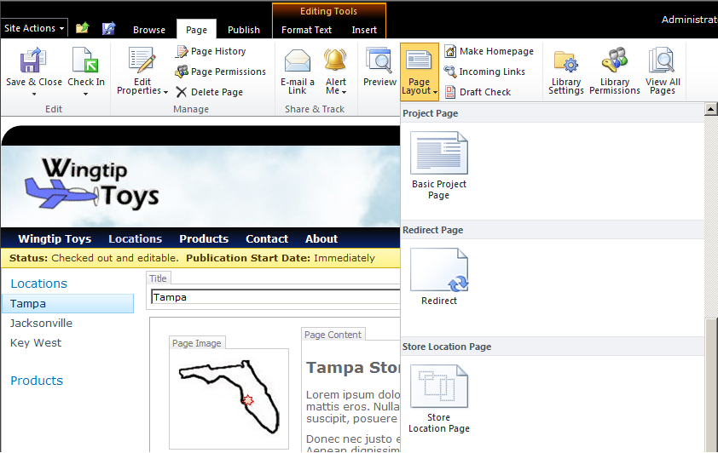

1. You should now be able to work with your page layout going back between edit mode and display mode.

